Read the poem and now answer these questions:

1. What time of day is it in the poem?

2. Find and copy **two things** the star saw when she looked down.

3. What did the star give to the pool to keep?

The moving sea a jewel her light

4. Look at line 4. Why is the star’s face described as ‘mirrored?’

5. Find and copy the line which shows us the pig disturbs the peaceful setting.

6. 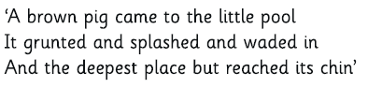Ww

W

What do these lines tell us about the depth of the pool?

The Star

